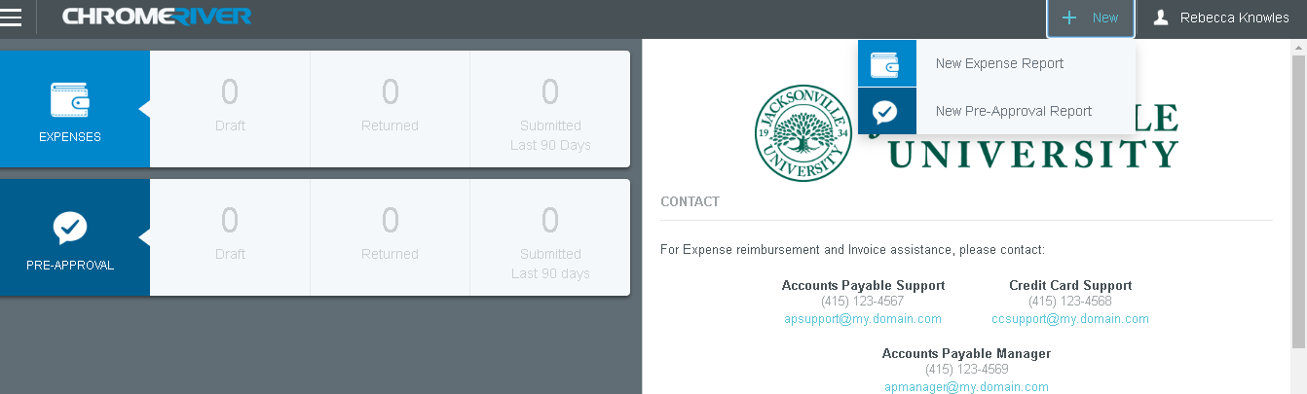
Step 1: After logging in, click the +New button, then New Expense Report

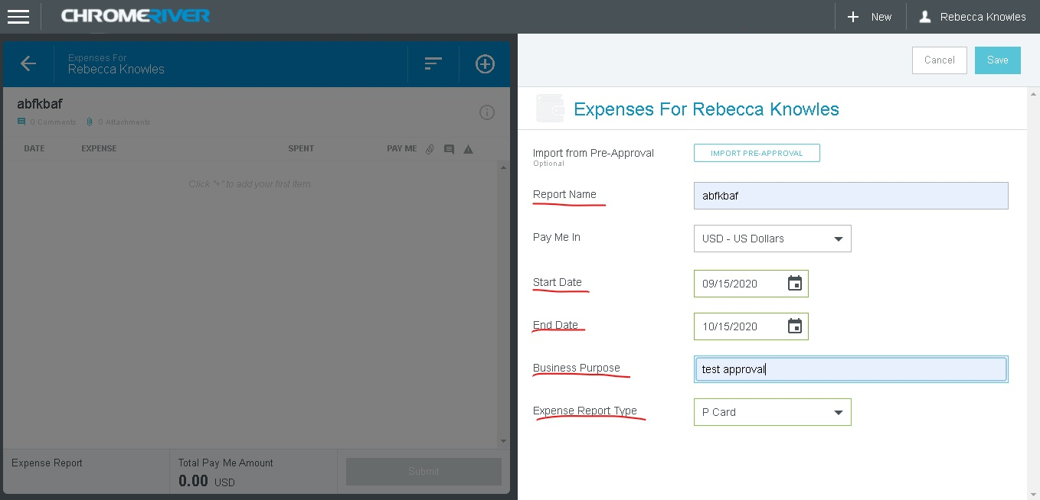
Step 2: Fill in the following information on “Expenses” pages
- Report name
- Start and End date
  - These dates will be the beginning and end dates of the PCard cycle
- Business purpose
- Expense Report type
Once this information is complete click the save button at the top right

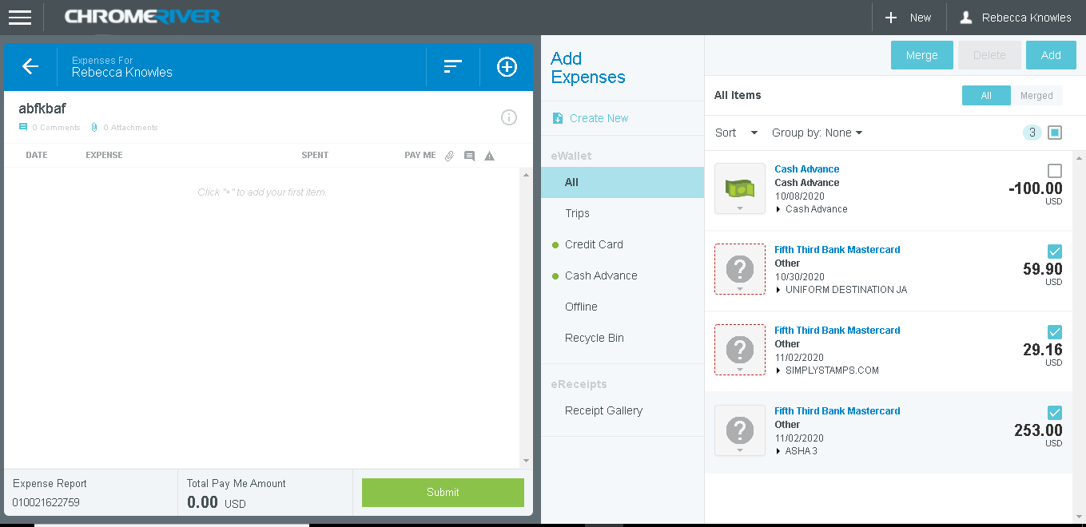
Step 3: Click the “credit card” button to show all credit card transactions
- To add transactions to your report click the box to the right
- Once all transactions have been selected click “add”

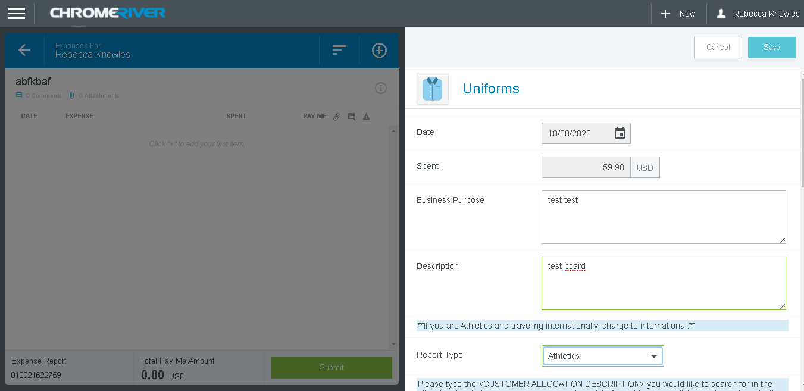
Step 4: Credit card transactions you have chosen to add to your report will appear as such above
- Chromeriver technology will match transactions to an object code
  - Above you’ll see an object code is already pre-chosen
    - If this object is code is not correct, you can click the tile (shirt circled in red) to change it
    - From here a new selection of object tiles will populate for you to choose from
- If the object coding is correct, fill out information underlined in red
- Before proceeding, DO NOT forget to choose a report type (read message in asterisks)
  - This is important for reporting an any additional approvals

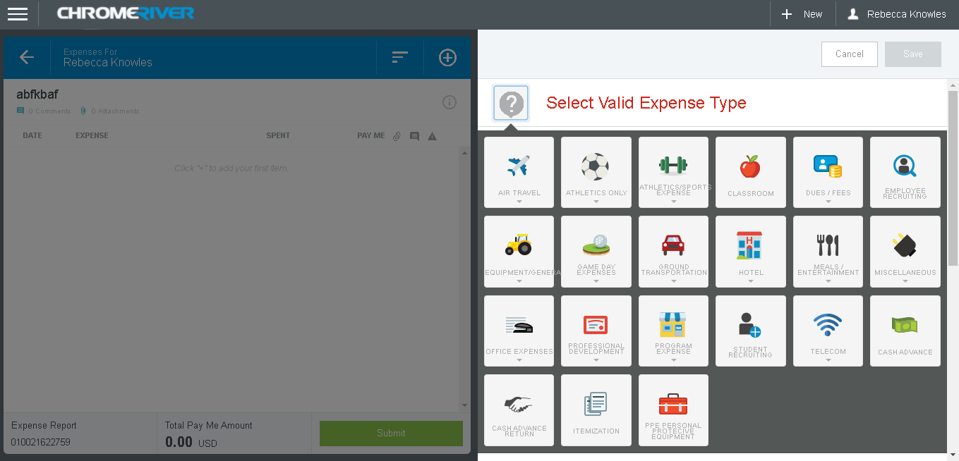
Step 4A: In the rare occasion charges are not recognized by chromeriver, the following will populate
- You will then select an object code from the tiles above
- From here you will complete Step 4 (see screenshot )
- You will complete the required information before moving on

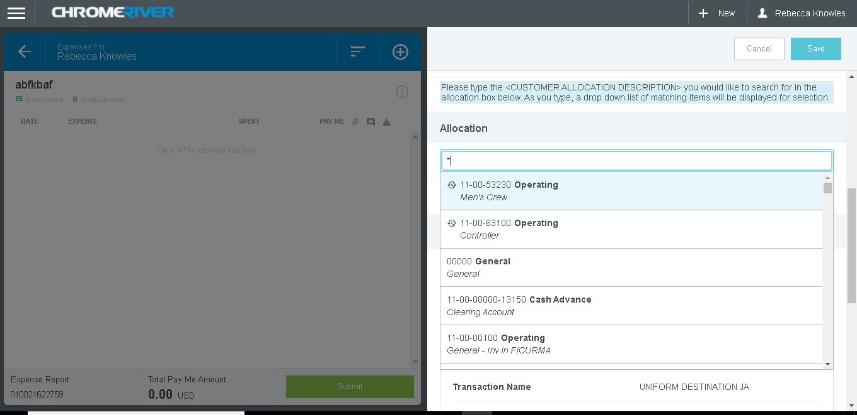
Step 5: Choose the GL account allocation for your charges.
- NOTE: shift* will get all GL accounts to populate on the dropdown menu
- Accounts that you have chosen before will automatically be populated in the menu
- Select the appropriate account for your charge to be allocated to

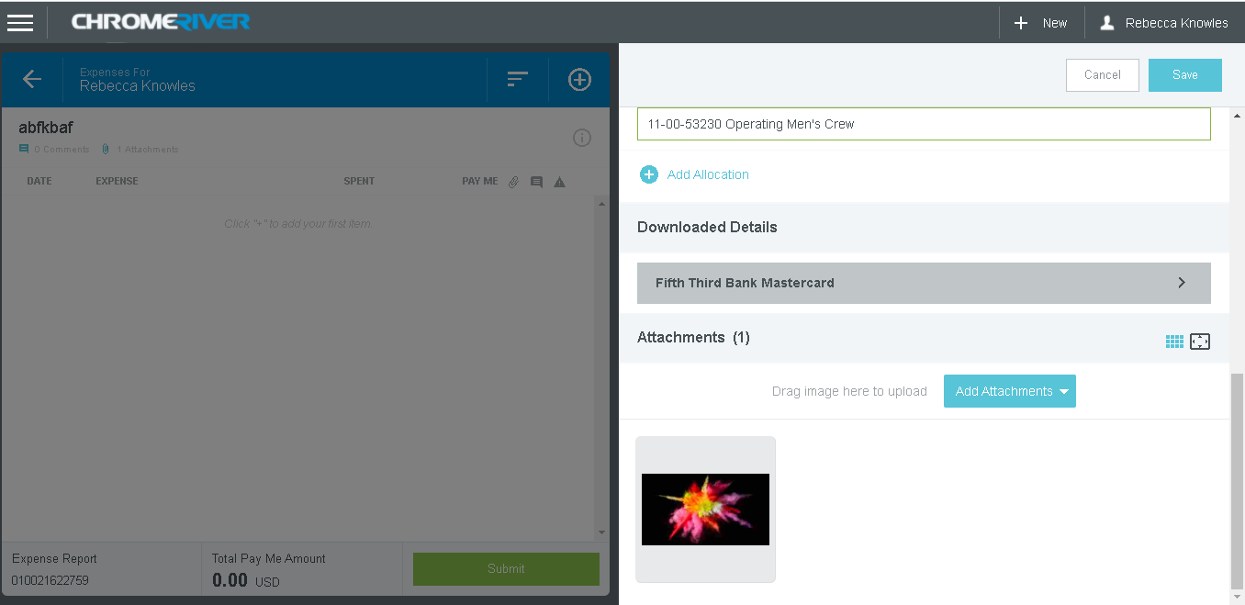
Step 6: Attach receipt(s) for your charges
- You can attach receipts 2 ways
  - Attach from the receipt gallery
    - These are receipts saved into chromeriver
  - Attach from computer
- Once you have the receipts attached, the will populate at the bottom of the screen
- After this click the blue save button at the top right

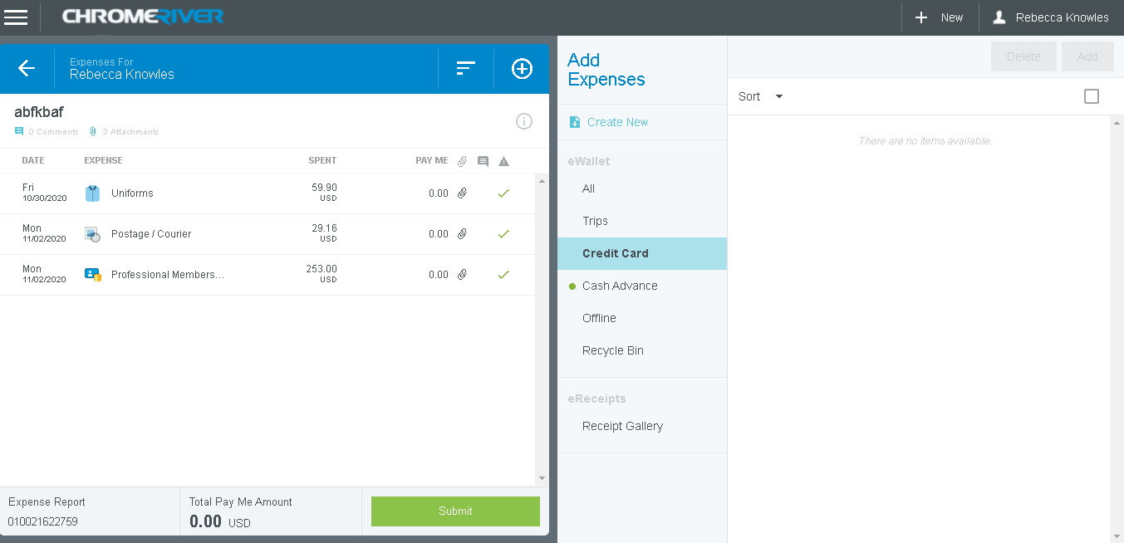
Step 7: Review charges added to report
- After coding (if needed) and allocating all charges for the report, they will appear on the left (shown above)
  - If you have any additional charges to add (credit card section in blue)
    - Repeat steps 3-6
- Please review charges listed for report (left side of screen)
  - If all looks correct click green “submit button”

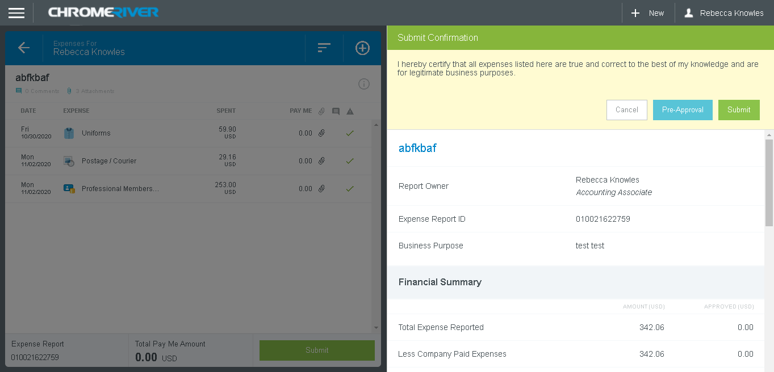
Step 8: Final additional confirmation before submission
- Prior to clicking the green “submit” button again, verify the following
  - On right side of screen all items underlined in red
  - On left side of screen all expenses (NOTE: the “Pay me” amount should be $0)

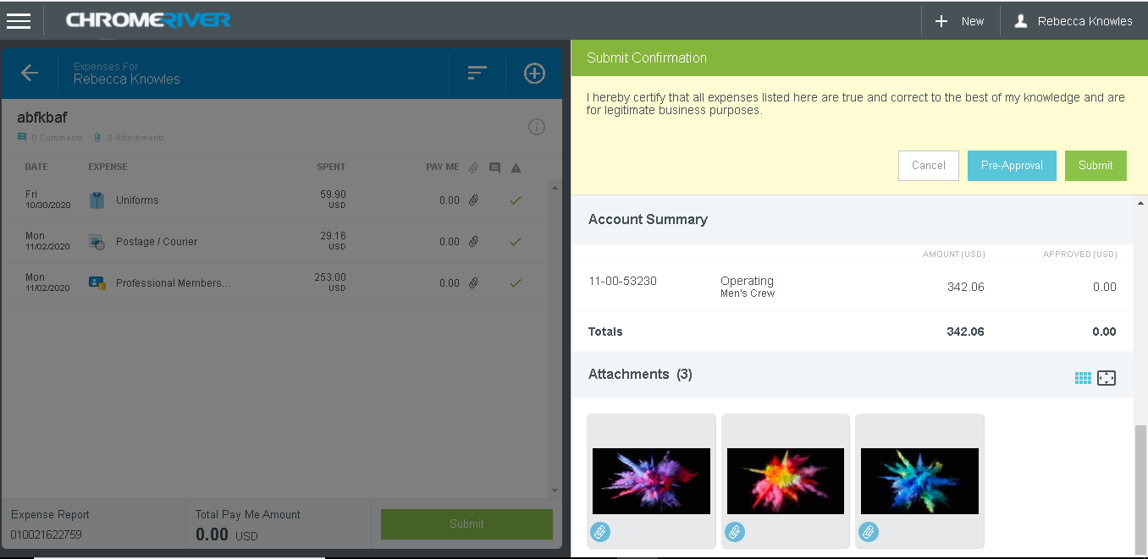
Step 8A: Final additional confirmation before submission
- Prior to clicking the green “submit” button again, verify the following
  - On right side of screen all items underlined in red
  - On left side of screen all expenses (NOTE: the “Pay me” amount should be $0)
  - Scroll a bit further (right side) to allocations and receipts to verify those as well

Step 9: Submission
- Once all allocations, receipts, charges, and additional items have been verified, click green “submit” button
  - This will send the report to your immediate supervisor for approval
  - Depending on account coding used for allocation, your PCard report could need additional approvals
  - Chromeriver will provide emails once approved at every step

