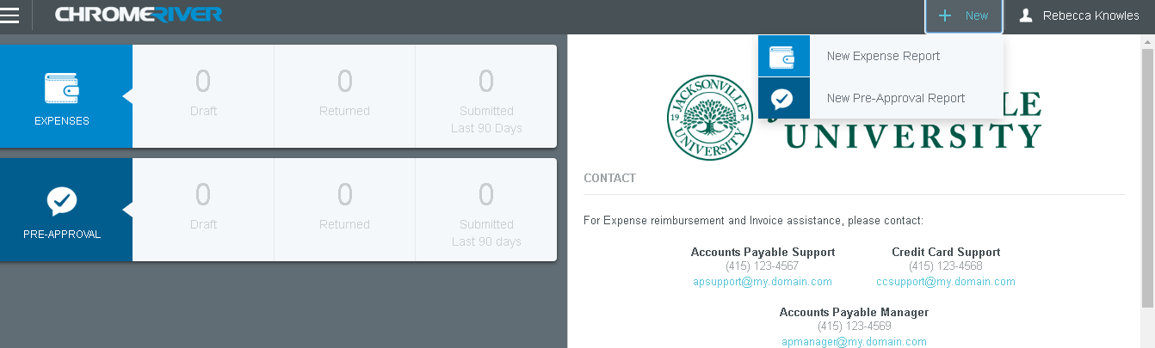
Step 1: After logging in, click the +New button, then New Expense Report

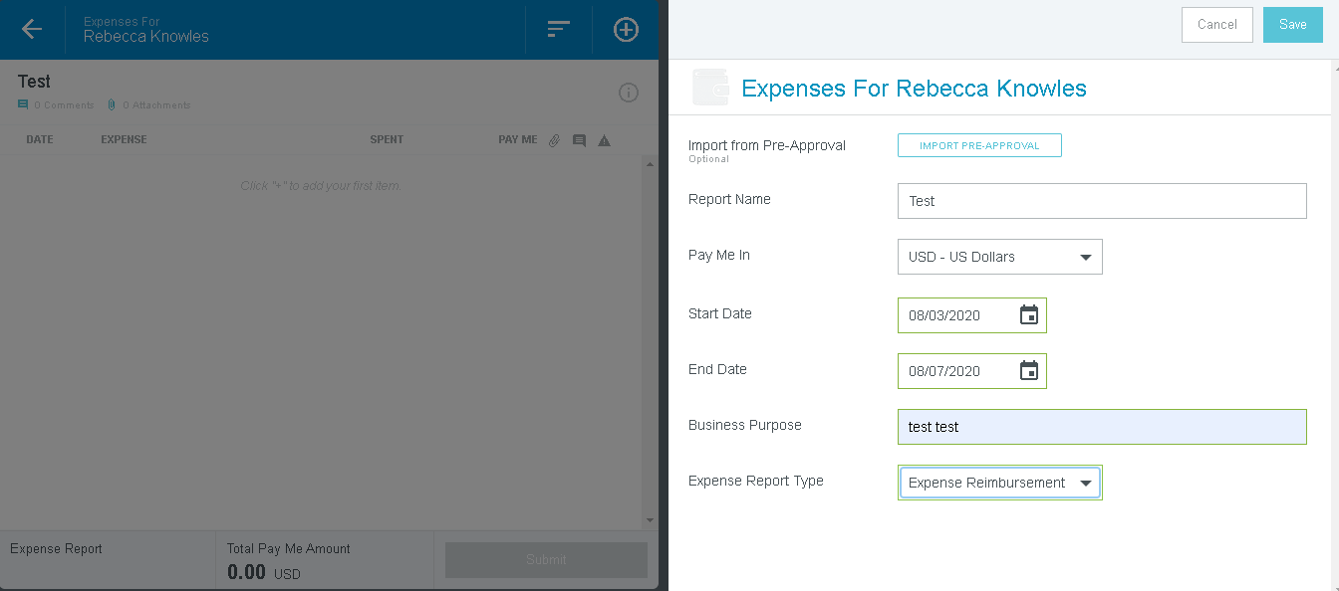
Step 2: Fill in the following information on “Expenses” pages
- Report name
- Start and End date
- Business purpose
- Expense Report type
Once this information is complete click the save button at the top right
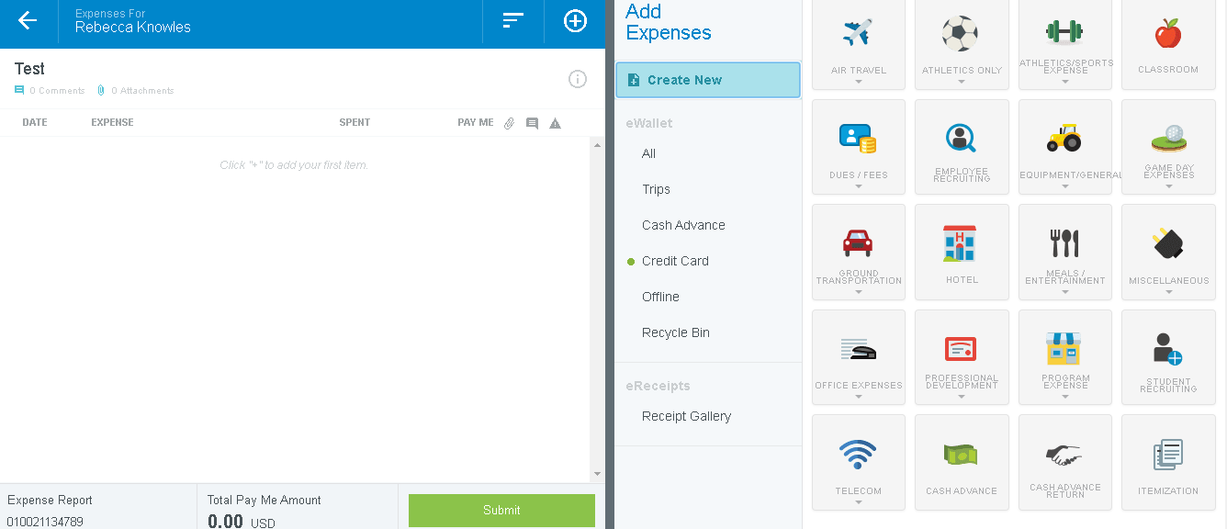
Step 3: Click the “create new” button to add expenses to your expense report
This will bring up the expense options for you to choose from

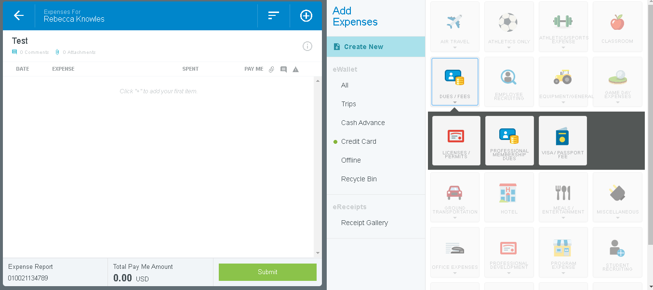
Step 4: Select your appropriate expense to add
- Example: for dues and memberships click “dues and fees” then professional memberships to add

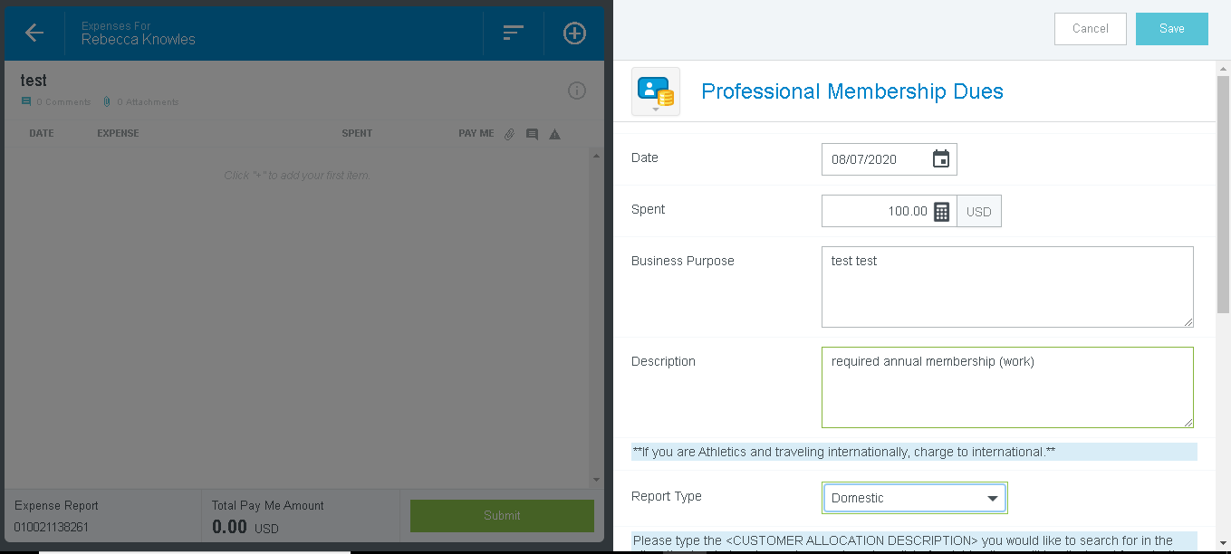
Step 5: After selecting your expense you will fill in the following information
- Spent
- Description
- Report type (please be mindful of the message in asterisks)
  - Be sure you are selecting the appropriate option from the dropdown menu
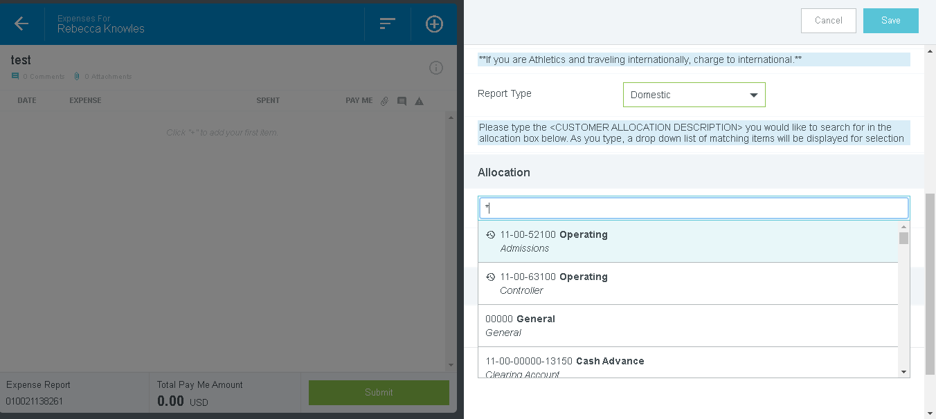

Step 6: After completing step 5, scroll down the page to the allocation section
(For first time users choosing an account, you will need to SHIFT * for all of the accounts to appear on the dropdown list)
You will then select the appropriate account for your expense

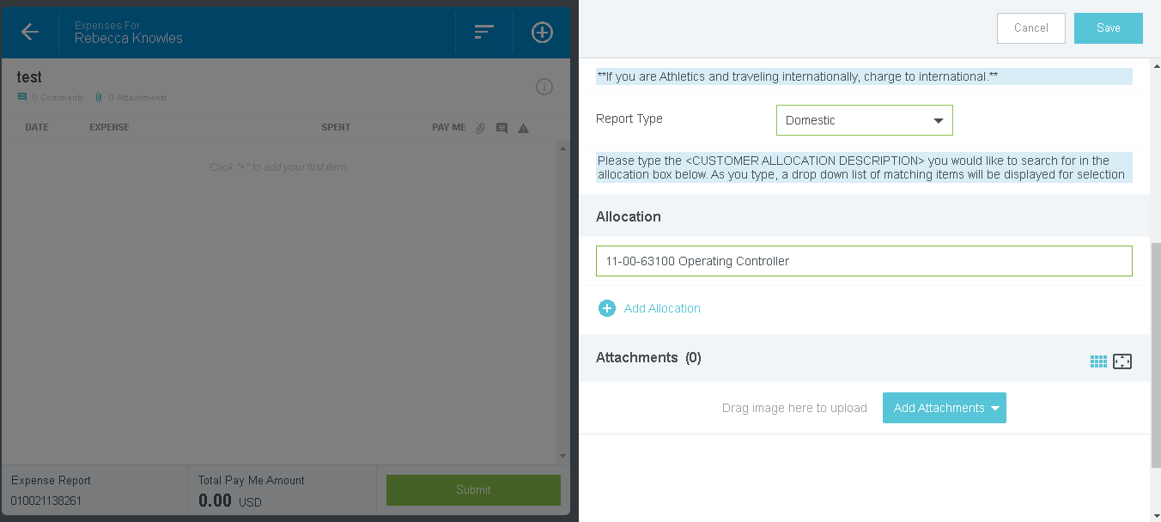
Step 7: Once you have selected the appropriate account for your expense, click it, and it will appear in the allocation box

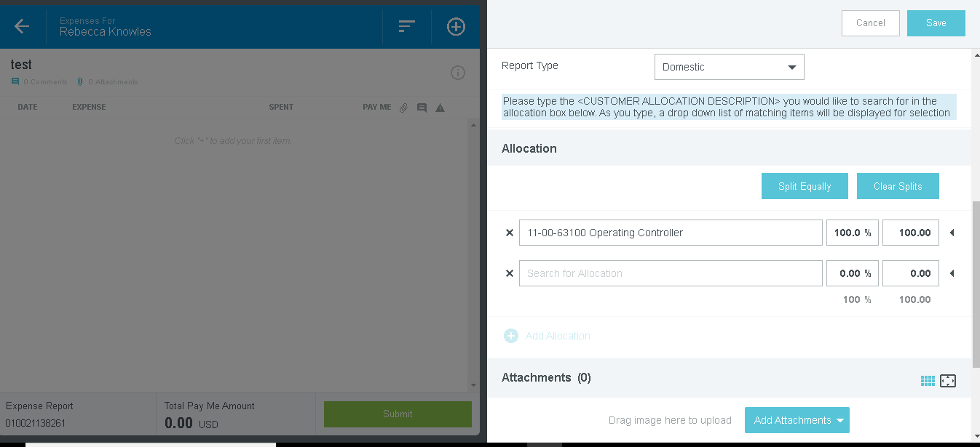
Step 8: If you have an expense that needs to be split between accounts, click “add allocation”
- Remember the SHIFT *
- Scroll to find the account
- Click to populate
- Enter dollar amount for each account

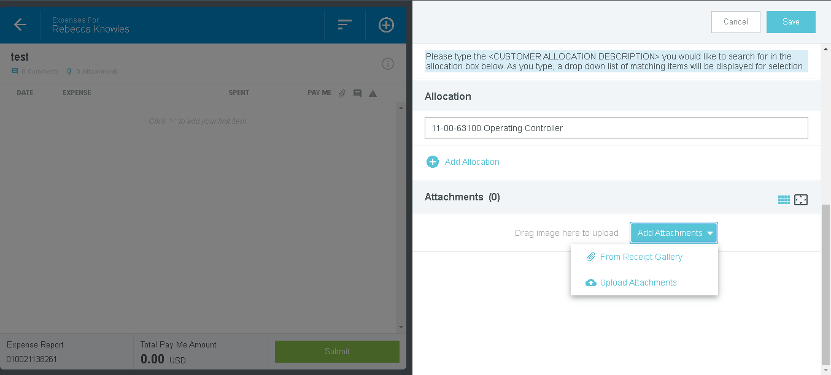
Step 9: Once account(s) are added, all expenses must have receipts.
- Click add attachments to upload your receipts
- From here you can choose which of the 2 methods you would like to use to add a receipt
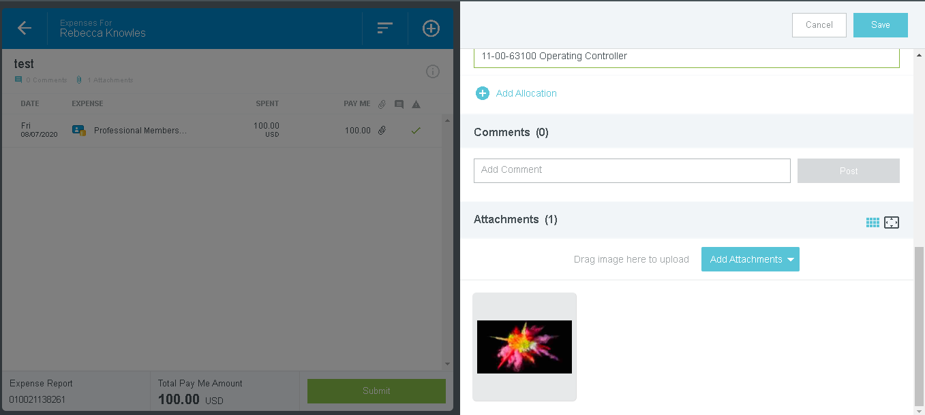
Step 10: Once you have added your receipt you will see it populate in the attachments section
- Please verify before submitting
Step 11: Once all information is populated, accounts are selected, and receipts are attached, click the blue save button at the top right

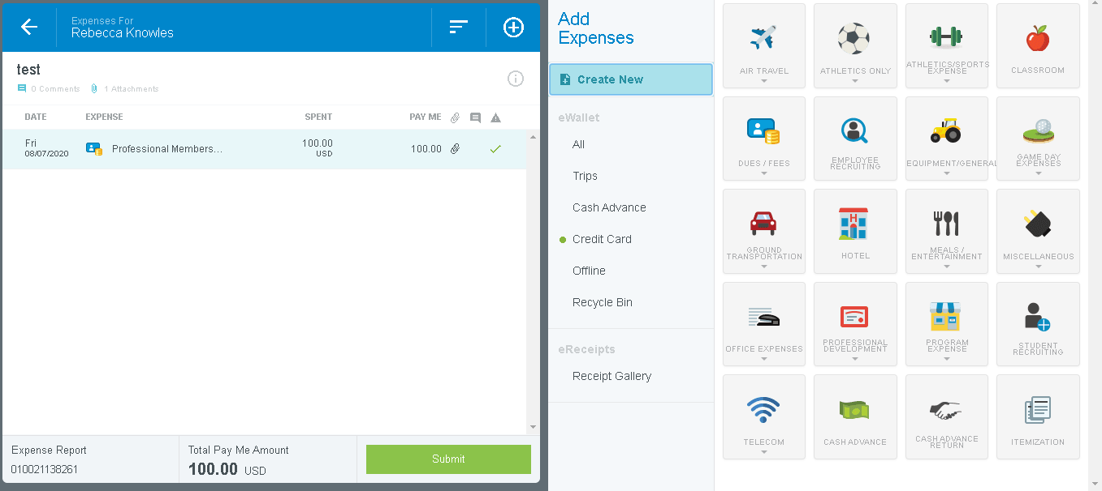
Step 12: (if needed) after adding an expense to your report and clicking “save” you will be brought back to this screen.
- More expenses to add?
  - Repeat steps 4-11 again
- Finished with report?
  - Click green submit button

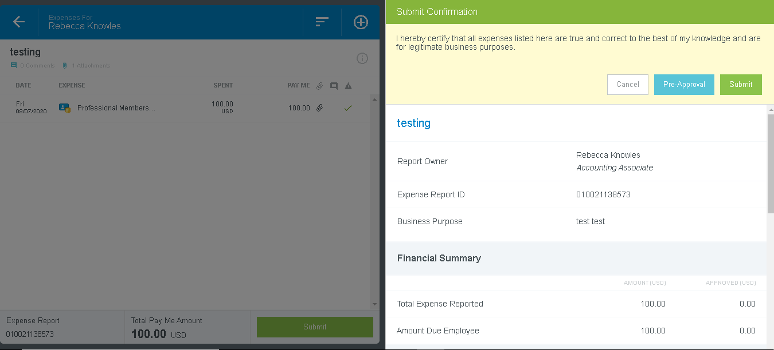
Step 13: After clicking submit, you will be brought to this page
- You will have a final opportunity to review what’s been entered
  - Scroll to check
- Once reviewed click green “submit” again
- Expense report will then be routed to your immediate supervisor for approval

